Intent - Phonics - The Oakmeadow Way | Implementation | Impact
What is phonics?  Phonics is best understood as a body of knowledge and skills about how the alphabetic system works, and how to apply it in reading and spelling, rather than one of a range of optional ‘methods’ or ‘strategies’ for teaching children how to read. Phonics give children the key to unlocking the alphabetic code for their reading and spelling.  Evidence shows teaching phonics is the best way to teach children to read. We use a systemic approach to teaching phonics– starting with the easiest sounds and progressing through to the most complex.  To teach word reading and spelling successfully, teachers need to understand the principles underpinning the teaching of word reading (decoding) and spelling (encoding). This understanding includes how the alphabetic code of English represent the sounds (phonemes) of the language with single letter and groups of letters (graphemes0.  Almost all children who receive good teaching of phonics will learn the skills they need to tackle new words. They can then go on to read any kind of text fluently and confidently, and to read for enjoyment.  At Oakmeadow, we believe that the best reading instruction for children with SEND is our systematic synthetic phonics (SSP) programme.  Phonics is a way of teaching children to read quickly and skilfully. They are taught how to:  * recognise the sounds that each individual letter makes;  * identify the sounds that different combinations of letters make - such as ‘sh’ or ‘oo’; and  ▪ blend these sounds together from left to right to make a word.  Children can then use this knowledge to ‘de-code’ new words that they hear or see. This is the first important step in learning to read.  Children who have been taught phonics also tend to read more accurately than those taught using other methods, such as ‘look and say’. This includes children who find learning to read difficult, for example those who have dyslexia. | At Oakmeadow we teach a daily phonics lesson in EYFS and KS1, moving into spelling focus following the security of phonic understanding.  Daily phonics lessons start as soon as children start their Reception year. Phonics session might only be 10 minutes long in the first few days. However, by the end of Reception, children will have about an hour a day to consolidate previous learning, learn new content, practice, and apply what they have learnt. These may be split into different sessions and different activities.  Phonics lessons use a Teaching for Mastery approach, which involve high-quality whole class teaching. Alongside this will be one-to-one and small group support for the few children who need extra help to ‘keep up’. Bug club phonics assessment will be used to support analysis of progress and identify next steps.  The daily teaching sequence will consist of : introduction, review and revisit, teach, practice, apply, assess learning. (Refer to Bug Club guidance for details).  Bug club phonics planning will be always used. Essential tips:  • The basic review and lesson elements of the teaching sessions are essential and should be carried out a a brisk pace. This may not be possible to begin with but the children get more used to the format the pace will quicken. The independent work provided by the PCMs and games can be tailed to meet the needs of individuals or groups.  • Ideally the sessions should be delivered on consecutive days, meaning, Units 1-12 will take around 16 weeks to complete.  • Teachers will need to use the interactive board to deliver lessons, along with small magnetic letter boards and letters for individual use or to share.  PACE and ORDER OF TEACHING  In Reception, Bug Club Phonics teaches a new grapheme and related phoneme in every Phoneme session. This fast pace is backed up by daily review of past teaching so that learning is commitment to the long-term memory. Keep-up sessions are provided for those that need it. As the basics 40+ phonemes are acquired quickly, early reading skills develop rapidly. Decodable readers are introduced after just 10 days of teaching at the end of Unit 2. This enables children to apply the taught strategies and enjoy contextualised reading early on. The order of the grapheme introduction ensure that children can start reading and spelling a wide range of words at the earliest possible stage.  All children should participate by listening and responding, and by practising and applying what they are learning. For reading, children should:  • Revise GPCs taught in earlier sessions  • Be taught new GPCs  • Practise reading words containing those GPCs  • Be taught how to read common exception words  • Practise reading ‘decodable’ phases, sentences and books that match the GPCs and exception words they already know.  • Teacher will model reading use their’ reading hands’ to help focus on segmenting and blending.  Children are encouraged to apply their phonic knowledge and understanding whenever reading and writing. Children are given books (decodable books) that have been carefully structured in cumulative steps for their learning to read, so that they can decode every word as their knowledge of the alphabetic code increases. When reading children at Oakmeadow use their ‘reading hands’ to help them focus on segmenting and blending new words.  For writing (spelling and handwriting), children should:  • Practise segmenting spoken words into their individual sounds  • Choose which letter or letters to represent each sound  • Practise a correct pencil grip  • Be taught the correct start and exit points for each letter, which should not include lead-in strokes from the line.  • Respond to dictation from the teacher, practising writing words in sentences that include only the GPCs and exception words they have learnt.  Dictation is a vital part of a phonics session. Writing dictated sentences that include words taught so far gives children opportunities to practise and apply their spelling, without having to think about what it is they want to say. At other time, children will be given tasks to allow them to practise and apply what they have taught to read and write independently, while the teacher helps those that need more support.  When writing all children have access to the appropriate phoneme mat which they use along with the Oakmeadow ‘action rhyme’ to help them spell new words. All children will be sat at a table for the writing part of the phonics lessons and will be using a pencil and paper. In EYFS and KS1 all children also have a ‘Phonic Workstation’ in their classroom which they use independently to help deepen their understanding of the phonics that they have been taught.  At the end of year one the children take the national phonic screening test at the end of the summer term and again in at the end of year 2 if they do not pass the  Phase Phonic Knowledge and Skills  Phase One (Nursery) Activities are divided into seven aspects, including environmental sounds, instrumental sounds, body sounds, rhythm and rhyme, alliteration, voice sounds and finally oral blending and segmenting.  phonic screening test the previous year.  Reception:  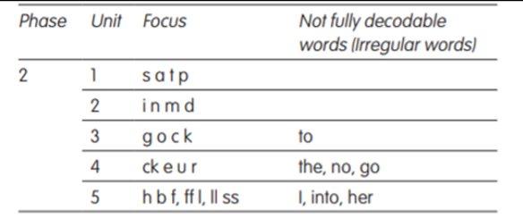  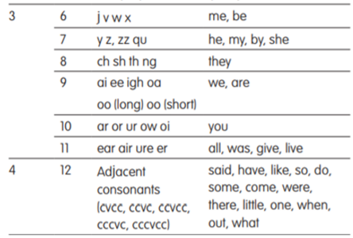  Units 1–12 support the suggested timetable for teaching Phases 2, 3 and 4 within the first year of school – for example, teaching four letters per week in Phase 2. The Units can take as little as 16 weeks to complete, but you should of course use your professional judgement to moderate the pace in accordance with the needs of the class. You may, for example, want to break for a week or so after you have finished introducing the single-letter phonemes, and use this time for assessment and catching up.  Year 1:  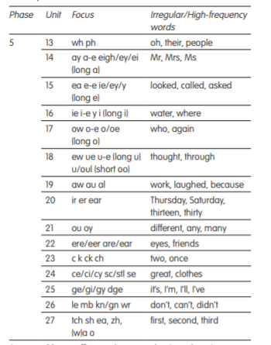  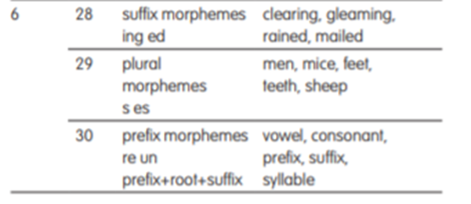  High frequency (common) words and irregular words  High frequency decodable common words are included for reading and spelling throughout Bug Club Phonics. These are listed below under ‘Decodable words’ and are always taught by sounding and blending. There is also a list of ‘Not fully decodable (irregular) words’; the term used in Letters and Sounds is ‘tricky words’. These words are subsumed under the heading ‘Irregular’ in the Language Sessions.  Reception example. Year 1 teach the tricky words for phase 5 and are included in the planning. It is essential that teaching and learning of the tricky words happens in order to develop fluency in reading.  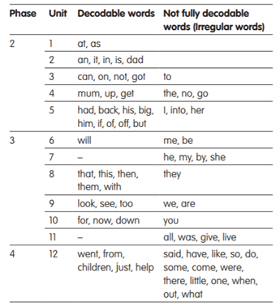 | Children enjoy phonics and believe they ‘can do’ apply their phonics knowledge to reading and spelling. They can use correct phonics vocabulary. Children apply their phonics skills to segmenting and blending and use their sounding hands to support this further.  Through the teaching of systematic phonics, our aim is for children to become fluent readers by the end of Key Stage One. This way, children can focus on developing their fluency and comprehension as they move through the school. Attainment in reading is measured using the statutory assessments at the end of Key Stage One and Two. These results are measured against the reading attainment of children nationally.  Attainment in phonics is measured by the Phonics Screening Test at the end of Year 1. However, we firmly believe that reading is the key to all learning and so the impact of our reading curriculum goes beyond the results of the statutory assessments.  We use effective systems so that children are supported in their ability to know more and remember more. There are regular opportunities to review the learning that has taken place in previous lessons. Lessons are planned using small steps to help secure learning to the long-term memory. Effective modelling by teachers ensures that children are able to achieve their learning intentions, with misconceptions addressed within it. There are effective ‘keep-up’ and ‘catch-up’ systems in place for those children that need more support.

