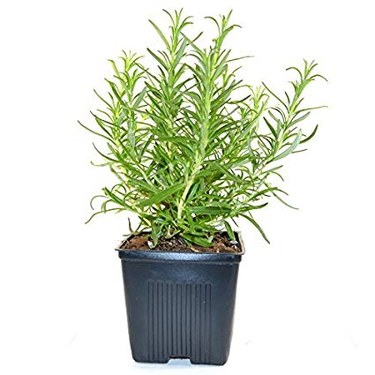
Monday 1st October
Growing Rosemary

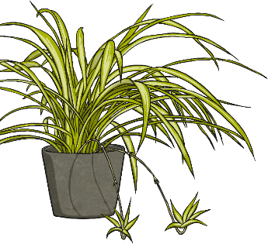
We know that not all plants need a male and a female part to reproduce and make new plants.
We learned that some plants reproduce asexually, meaning that cuttings can be taken from a ‘parent plant’ to make new plants. For example, spider plants send out branches with baby ‘plantlets’ on, which given the right conditions, will grow into new spider plants.
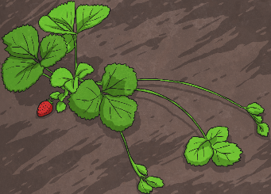
Strawberry plants send out runners with small plants on, and each of these (again, given the right conditions) will grow into a new plant.
Today, we took cuttings from a rosemary plant, and prepared them to allow them to grow into new plants.
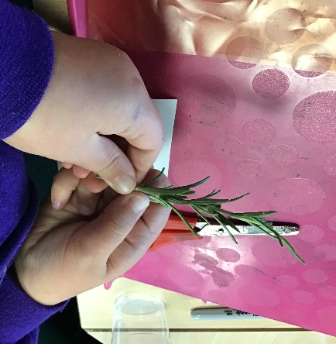
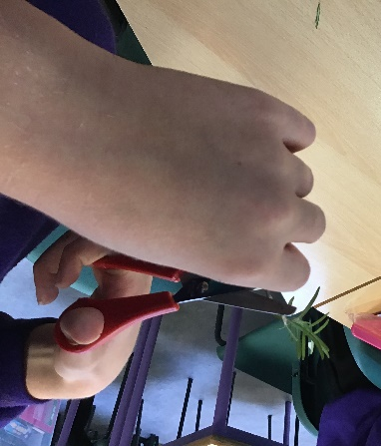
We took the leaves off the bottom of the stem so that the stem wouldn’t lose unnecessary moisture, then we followed instructions to cut the stem just below a leaf node as this is where the roots would have the best chance of growing from.
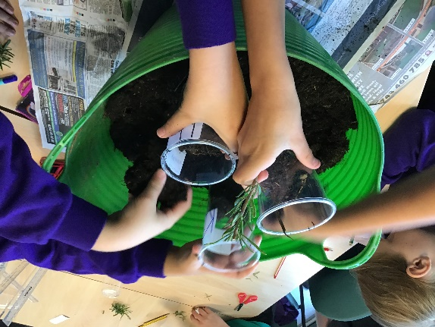
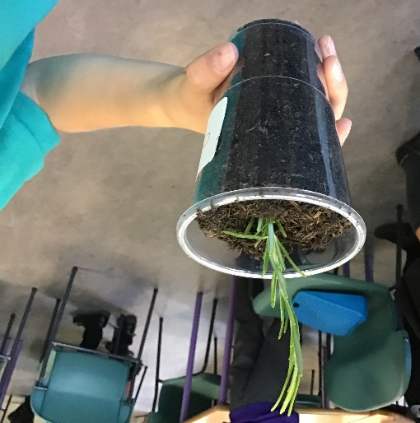
Once the cutting was prepared, we put it in compost and watered it a little to start the ‘growing’ process. We’re excited to see how it changes in a few weeks.

