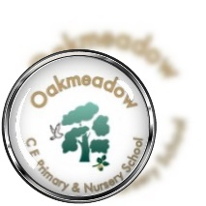
Oakmeadow CE Primary School
Bayston Hill
Shrewsbury Shropshire
SY3 0NU
Tel No: 01743 875020
Email: admin@oakmeadowprimary.co.uk

Dear Parents/Carers,
School Councillors
We are pleased to let you know that your child has been selected to be a school council representative for their year group across the school year of 2023-2024. We wanted to write to you to let you know what this role will involve for your information.
At Oakmeadow, we have two school council members per class. Mrs Done and Mrs Davis will be supporting all school council reps in their role and will help the councillors decide on and act on the agenda for the year. Each class will be given time for discussion before the meetings take place. This way councillors are able to bring the opinions of their peers to the meetings, pupils have their voices heard and all children are in charge of improving their own school. Our reps will be given time to feed back to their classes following meetings to keep everyone updated on progress. There will also be a display board where children can monitor progress of our wider agendas across school.
We will work with our school council team to develop their listening, knowledge, and communication skills which in turn will allow them to be confident and supportive members of their school community. They will be able to seek support when necessary whilst effectively supporting and guiding other children.
Being a councillor is a very responsible position and the children involved play an important part in developing Oakmeadow for the better. This is a great leadership opportunity for your child and will develop their confidence with speaking, listening and being super role models for their school community.
If you have any queries, please do not hesitate to get in touch via admin@oak.mmat.co.uk and ask for Mrs Done and Mrs Davis.
Kind regards,
Mrs Done and Mrs Davis

