Nursery Admissions Policy

Oakmeadow CE Primary School and Nursery aims to provide a quality nursery experience for children, from aged 2-4 that is affordable, high quality and geared towards a smooth transition into Reception class. The information is written to help parents understand our procedures that ensure fairness and equality for all those intending to begin their education at Oakmeadow CE Primary School and Nursery.
- Admissions procedure
A visit is arranged with the Nursery manager to show prospective families around, answering any questions they may have.
A ‘Session enquiry form’ will be completed by the family, giving details of the days and times they would like their child to attend. We encourage families to request sessions for the academic year, as we cannot guarantee an increase of sessions throughout the year. We suggest that families book more than one session (day) per week for their child, as this supports with the settling in process.
Once a session enquiry form has been completed, you will receive confirmation of whether we are able to accommodate your request for sessions.
If your request is accepted, you will receive details of two induction dates for your child to attend, prior to their start date. Registration forms will be sent in advance of the induction date and will be required to be returned for when your child attends their drop-in sessions.
- Free childcare arrangements
Oakmeadow Primary School and Nursery can accommodate a maximum of 40 children across the nursery; 8 children in our two year old room and 28 children in our 3-4 year old room.
The nursery is able to offer 30 hours free childcare as an extension to the universal 15 hours free childcare, for children aged 3-4 years. Eligible parents are able to access the 30 hours of free childcare the term following their child’s third birthday. To check your eligibility for 30 hours free childcare, please visit: www.childcarechoices.gov.uk. The 30 hours can be accessed during term time, for 38 weeks out of the school year. If eligible, parents must provide school with their unique code to confirm they are eligible for the scheme, together with their National Insurance number and parent’s date of birth. As the free childcare cannot be claimed until the code has been verified, parents should provide the school with this information as soon as possible in order to avoid delay.
The sessions offered to nursery children are as follows:
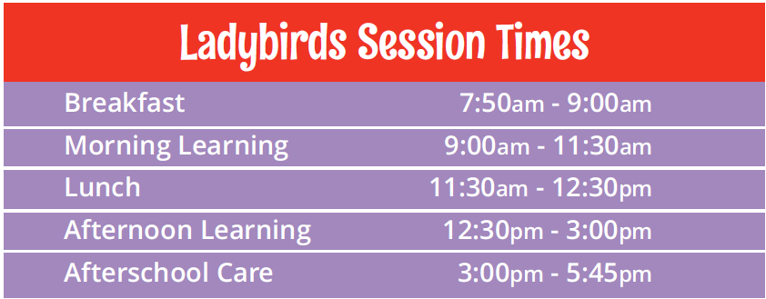

- Paid provision
We also offer paid provision in addition to funded hours. Invoices are sent half termly and payment is required in advance of these sessions via school money. Payment is required within 14 days of the receipt of the invoice. Please note you will not be charged for bank holidays and PD Days when the nursery is not open.
Please see below table for details of cost per session.
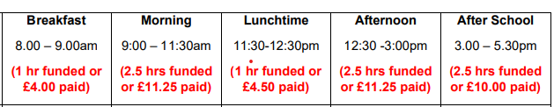
Please note there is a late collection fee of £10 for every 15 minutes. There is no refund if your
child misses a session due to illness or holiday.
A discount of 20% for paid provision is offered for children of Oakmeadow Staff who wish to
attend the nursery.

- Oversubscription criteria
Where the number of nursery applications exceeds the number of spaces available, we will use the following criteria to prioritise applications for both funded and paid hours when space become available.

Priority 1 – Looked after children or children who were looked after but immediately after being looked after became subject to adoption, a child arrangements order or special guardianship order.
Priority 2 – Children with an exceptional medical or social need to attend nursery.
Priority 3 – Children who live within the catchment area and are eligible for the two year old funding.
Priority 3 – Children who live within the catchment area and have a sibling at school.
Priority 3 – Children who live within the catchment area.
Priority 4 – Children living outside the catchment area.

- Complaints
If you are unsatisfied with any decision made has been made through the admissions procedure, please contact the head of school on 01743 875020 to make an appointment or email Samantha.hill@oak.mmat.co.uk

