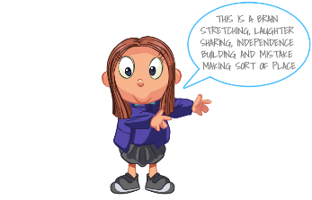
Oakmeadow CE Primary School
Bayston Hill
Shrewsbury Shropshire
SY3 0NU
Tel No: 01743 875020
Head teacher: Deputy Head teacher:
Mrs C Whelan BA (Hons) QTS NPQH Pg Cert Mrs S Hill

Contact: Email: admin@oakmeadowprimary.co.uk Information: www.oakmeadowprimary.co.uk
Appendix 5: Parental Agreement for School to Administer Medicine
All medicine must be handed to the school reception by a parent/carer and collected at the end of the day. No medication will be hanned over to a child.

The school will not give your child medicine unless you complete and sign this form.
Name of child
Date of Birth
Class
Medical condition or illness

Name & Phone no. of GP

Name/Type of Medicine
(as on the container)

Dosage & Method

Are there any side affects
the school need to be aware of?
Procedures to take in an emergency
Contact Details | Name
 | Telephone no.
 | Relationship to child
 | Address

I accept that this is a service that the school is not obliged to undertake. I understand that I must notify the school of any changes to my childs medication in writing.
Signature:_____________________________ Date:____________________________

Please note: it is your responsibility to ensure that the school is kept informed about any changes to your child’s medicines, including how much they take and when. Is is also your responsibility to provide the school with medication that is clearly labelled and in date.

