Intent - Reading - The Oakmeadow Way | Implementation | Impact
We fully believe at Oakmeadow that competence in reading is the key to independent learning and has a direct effect on progress in all other areas of the curriculum. We want our children to be ‘readers’, not just children who can read. Meek (1983) believes that, ‘Readers are made when they discover the activity is worth it.’  Guided Reading is an opportunity to complete targeted specific learning in word reading/decoding and comprehension skills. We believe the benefits that a consistent and regular delivery of this can have great impact on the attainment and progress of children.  Consistency of delivery of guided reading across school has contributed to high levels of attainment and progress in Reading. Children read in a small group situation to improve outcomes  Lessons will be planned using the content domains as an underlying approach, whilst having a teaching process that focuses on the skills of understanding of what is being read and creating a love of books, ensures that children have skills that last beyond school. It also promotes a passion for reading, a thirst for knowledge and a love for learning which lasts a lifetime.  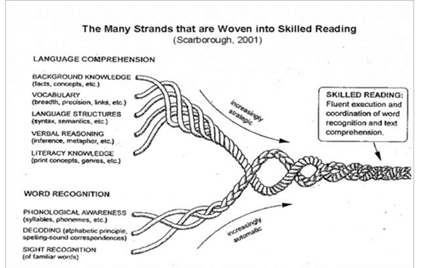  Guided Reading runs alongside opportunities children are given to read individually to an adult. Vulnerable readers (those who are not having ample opportunities at home or are on pupil progress) are heard read daily by an adult in school and this is logged.  Questioning and checking for understanding are essential elements of Guided reading | Guided Reading is be planned to take place daily, or discussed at pupil planning meetings to run in line with assessment priorities. Where GR is taking place daily, each child will take part in a teacher led group at least once a week, preferably more. Flexibility with timings may be appropriate for lower school to cater for attention and concentration abilities. The English coordinator is communicated with regarding any variations.  Material used in Guided Reading should be at, or ideally a level above (once on blue band), the book band that the children are currently working on to aid progression. Guided Reading is recorded in an agreed format, and this provides an evidence bank for teacher assessments in Reading.  Staff consider the following principals for guided reading with early readers:  • decide how to organise children into groups so they can practise reading a ‘decodable’ book or text. This might be within the main class or group phonic lesson, or in groups throughout the day  • choose the book or text that matches most closely the GPCs that the group  • take account of the children’s ability to blend the sounds in words that are unfamiliar  • note which words might need explaining  • clarify the purpose of any re-readings: to increase the number of words children can read ‘at a glance’, or perhaps to discuss the plot of the story, the characters and their motives deciding which ‘decodable’ book the children will take home to read.  • As their knowledge of GPCs and the words they can read ‘at a glance’ increases, the children can gradually read longer books.  For readers that are more fluent, the guided reading session will develop comprehension skills. Teachers plan questions based on the content domains with a focus on developing retrieval, inference and word meaning skills.  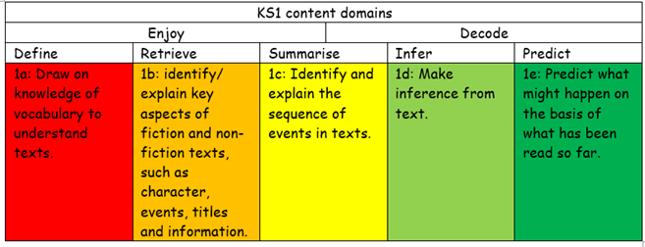  Staff consider the following principals for guided reading with more fluent readers:  • Share focus with groups/class  • Read with individuals rather than ‘group read’ – listen to each child, when appropriate.  • Group reading – pace set by the teacher  • Modelled reading  • Modelled answering questions: answer, explain, and prove strategy when appropriate.  • Rich discussion on questions  • Children recording their individual responses on w/b or post-it notes.  • Guided sessions to be planned predominately with a novel but can be supplement with a variety of other genres eg non-fiction, songs, poetry etc. (consider strategies to allow children to read the whole book eg read ahead).  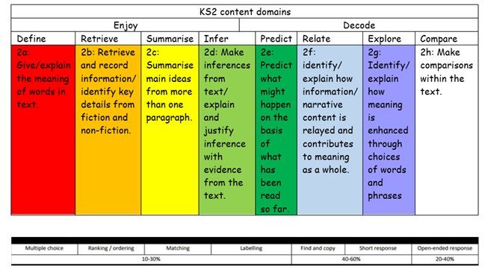  We follow a carousel approach mainly within school where children should have opportunities to read for pleasure, to access online targeted materials (Bug Club) and to respond to what they are reading in written, oral and pictorial formats that promote comprehension skills. We are open to the whole class guided approach and this is being trialled in classes. This needs prior agreement from the English Coordinator and SLT.  All teachers will have a folder for guided reading and use assessment sheets to triangulate their teacher assessment of children’s progress. | We firmly believe that reading is the key to all learning and so this impact of our reading curriculum goes beyond the results of the statutory assessments. We give all children the opportunity to enter the magical worlds that books open up to them. We promote reading for pleasure as part of our reading curriculum. Children are encouraged to develop their own love of genres and authors and to review their books objectively. This enhances a deep love of literature across a range of genres, cultures and styles.  Through the teaching of systematic phonics, our aim is for children to become fluent readers by the end of KS1. This way, children can focus on developing their fluency and comprehension as they move through the school. Attainment in reading is measured using the statutory assessments at the ned of Key Stage One and Two. These results are measured against children nationally. Attainment in phonics is measured by the Phonics Screening Test at the end of Year 1. Phonics is tracked termly from Nursery against phased sub-levels.  Children enjoy their guided reading lessons and learn to apply the different skills within the reading domains, so they really comprehend the wide variety of texts they read.  As a Year 6 reader, transitioning into secondary school, we aspire that children are fluent, confident and able readers, who can access a range of texts for pleasure and enjoyment, as well as use their reading skills to unlock learning and all areas of the curriculum. We firmly believe that reading is the key to all learning and so the impact of our reading curriculum goes beyond the results of the statutory assessments.  In addition to this:  Parents and carers will have a good understanding of how they can support reading at home, and contribute regularly to home-school records.  The % of pupils working at age related expectations and above age-related expectations within each year group and will match the ambitious targets of individual children.  There will be no significant gaps in the progress of different groups of pupils (e.g. disadvantaged vs non-disadvantaged)

