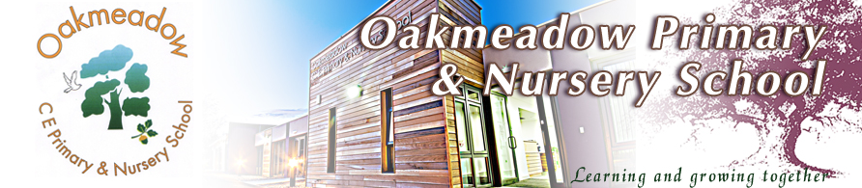



**Oakmeadow CE Primary School**

**Bayston Hill**

**Shrewsbury Shropshire**

**SY3 0NU**

**Tel No: 01743 875020**

**Email:** [**admin@oakmeadowprimary.co.uk**](mailto:admin@oakmeadowprimary.co.uk)

**Website:** [**www.oakmeadowprimary.co.uk**](http://www.oakmeadowprimary.co.uk)

Dear Parent/Carer

From September 2021, your child’s new class will be Hedgehogs.

Your child's teacher will be Miss Davies



**Introduction from the class teacher**:

Hello and welcome to Hedgehogs class! My name is Miss Davies, and I will be your child’s teacher next year.

Here is a little bit of background information about me. I am currently entering my second year as a teacher, after teaching a year four class in Telford during my first year. I have been fortunate to spend my entire life growing up in the surrounding area. I live in a village just outside of Shrewsbury, and I love spending time in the countryside. I am incredibly passionate about creating an exciting classroom environment for you all. I love to have fun and there is always laughter whenever you step foot into my classroom. I am an avid football fan, and you will need to be prepared for lots of football chat over the coming year. If you support Shrewsbury Town, you’re in luck! My favourite way to relax and unwind is by reading a good book. I have a (very) large collection of books that you will have complete access to. I am so excited for all of the fun memories we can share over the year ahead!

Unfortunately, due to the current circumstances we will be unable to have our usual move up fortnight where you get to move into in your new classroom with your new teacher and Teaching Assistant. To replace this, I will be shortly posting a video of your new classroom together with some information about the exciting work we’ll be starting in September when we look forward to welcoming you all back to Oakmeadow.

If you have any questions about the year ahead, please do not hesitate to contact me.

Best wishes

Miss Davies